Balochistan Federation of Trade Unions is registered federation and working for the benefits of trade union and pensioners rights.

The trade union movement in Pakistan can be traced back to this pre-indepen



dence period. The wage earning class that emerged in the sub-continent due to the introduction of railways and agriculture plantation was the beginning of the trade union movement.

The establishment in 1919 of the International Labour Organisation (ILO) greatly inﬂuenced the growth and development of trade union movement throughout the world. The arbitrary selection of delegates for the ﬁrst session of ILO by the Government of India was greatly resented by the trade unions and they organised a convention, where it was decided to form a central organisation of workers namely, All India Trade Union Congress (AITUC). Quaid- e Azam Mohammad Ali Jinnah attended the founding conference of AITUC held on 30 October, 1920 in Bombay. The passing of the Indian Trade Union Act, 1926 and Trade Dispute Act, 1929 gave formal recognition to the workers’ right to organise and settle disputes between parties. The adoption of Convention 87 on right of association and Convention 98 on right of collective bargaining by ILO and the ratiﬁcation of these important ILO Conventions by Pakistan in the earlier years after independence, paved the way for adoption of legislation favouring workers’ right of association and collective bargaining. The enactment of the Industrial Relations Ordinance, 1969 was a landmark for trade union movement in the country.

Trade union movement was initially opposed by the employers, because most employers at that time (early ﬁfties) were composed of the government (bureaucrats), particularly in sectors like railways, telecommunications, power and industries established by the Pakistan Industrial Development Corporation (PIDC). They followed the authoritarian tradition of colonial arena, against the participatory approach envisaged in modern industrial Relations. The employers in private enterprises also followed similar approach as that of public sector bureaucrats, and generally were not in favour of trade unions. The formation of trade unions was resisted and obstructions were created by a variety of methods, such as not recognising the trade unions, creating rival trade unions at the same plant and victimisation of trade union ofﬁcials. There were, however, exceptions too. For instance, as early as in 1951, a foreign company recognised the union and accepted all her legitimate demands. In return the union agreed to double the productivity. The company was able to attain human productivity comparable to its European plant by 1955. All foreign companies were however not alike. A foreign bank issued a written warning to its employees for joining trade unions.

Pension System Reforms for Pakistan: Current Situation and Future Prospects
https://pide.org.pk/pdf/publications/Monograph/Monograph.pdf

- Awaiting justice
The Employees Old-age Benefit Institution (EOBI) pensioners have in light of soaring inflation asked an increase from Rs5,230 per month to Rs15,000 for those over 80 years of age and Rs10,000 per month for those under eighty years. The government has announced a relief to employees both in military and civil sectors in the coming budget of 2018-19. The lower ceiling is being increased from Rs6,000 to Rs10,000 per month. Unfortunately the pleas of EOBI pensioners have gone unheeded by the government.
The last time the EOBI pensions were raised was April 01, 2015 to Rs5,250 per month after three years (the last was Rs3,600 in 2012). ‘Former chief justice Iftikhar Muhammd Chaudhry on June 29 had taken suo motu on a note of the SC registrar. According to the note, the EOBI had allegedly caused a loss of Rs40 billion to the national exchequer by investing huge amounts in private sector projects without approval of its Board of Trustees (BoT).’ (Local newspaper, May 26, 2017) Reportedly the government also did not transfer EOBI funds to provinces under the 18th Amendment.
‘Established in 1976 during the PPP government, the EOBI operates under a mechanism whereby government employees contribute 1pc of their salary each month and the employ 5pc to the institute. The EOBI is responsible for remunerating the employees upon their retirement. The EOBI is also authorised to invest money to increase its capital.’
Justice Azmat Saeed, in a Supreme Court hearing, reportedly expressed his displeasure over the amount being paid to the pensioners under Employees Old-age Benefit Institution (EOBI). (Business Recorder April 18th, 2018) “The figure Rs5,250 is not acceptable to us.” “Our concern is baseline figure,” Justice Azmat Saeed Sheikh told the advocate generals of all the provinces.
Owing to overburdened debt, rising inflation lesser opportunity for elders to find gainful employment, one can understand the pressures on the government to offer a very high rate of retirement income rate
What we need is a comprehensive system where those who retire have a decent quality of life including healthcare and other necessities without having to depend on anyone else. After a lifetime of service this is their right.
In United States for example retirees get income from social security, people during work pay through direct tax that go to create a federal social insurance programme. This forms the basis of their retirement income. Medicare services offered offers national health coverage, but even in a developed country like US elder people lack a separate insurance umbrella for medical coverage.
France has a system that caters for inflation. For those having worked in the private sector, pension is calculated on the 25 best working years of a private worker’s life, it adds a percentage for inflation over a given number of time, and adds it to the pension this amounts to a total of fifty per cent of their total monthly income.
Denmark offers a public base pension plan. There is in addition a supplementary pension benefit as well as a 100pc funded contribution scheme and occupation schemes that are mandatory.
Organisation for Economic Co-operation and Development (OECD), which analysed data from its 35 member countries and a number of other nations, states that, “Pensioners in the Netherlands, Turkey and Croatia receive more than 100pc of a working wage when they retire. Indeed, Dutch and Turkish pensioners get 101pc and 102pc, respectively, but Croatians receive a generous 129pc.”(World Economic Forum 23 Feb 2018)
The wheel does not have to be created. One needs a critical study of what nations are doing in terms of retirement plans for their elderly, choose a well-rounded plan and mold it to the local needs.
One is ashamed to see on the government of Pakistan’s EOBI Pension Page:
Pension Rates:
- Minimum: Rs 5,250
- Maximum: As Per Formula
LINK: http://www.eobi.gov.pk/introduction/Pension.html
One would like to ask the concerned exactly what formulas are they talking about here? There is none. Why make a mockery out of the pensioners?
One option to handle the funds is to increase the age of retirement that allows the elders otherwise healthy and fit to remain in the work force. Nonetheless even if this is done it does not automatically translate to well-formed policies eventually once retirement comes.
Owing to overburdened debt, rising inflation lesser opportunity for elders to find gainful employment, one can understand the pressures on the government to offer a very high rate of retirement income rate. However, the sheer cruelty of ignoring the private employees sector in their old-age, bungle-ups by government and those running the organisation causing extreme financial distress to the former private employees cannot be excused nor can they be absolved of their responsibilities. It is due to the failure of the executive that the responsibility has once again fallen upon the shoulders of the Supreme Court to do justice to them.
There are three sources through which traditionally funds can be generated for retirement. Contributions via employee, employer or both, government support and investment income received by the pension plans. The government thinking out of the box may make it mandatory for companies to contribute towards the EOBI fund offering reasonable advantages in return.
In the meanwhile the EOBI pensioners await justice!

EOB Act 1976 was enforced with effect from April 01, 1976, to achieve the objective of Article 38 (C) of the Constitution, by providing for compulsory social insurance. It extends following benefits to insured persons or their survivors:-,
- Old-Age Pension
- Survivor's Pension
- Invalidity Pension
- Old-Age Grant
Please see the link http://www.eobi.gov.pk

Page 1 of 1

- 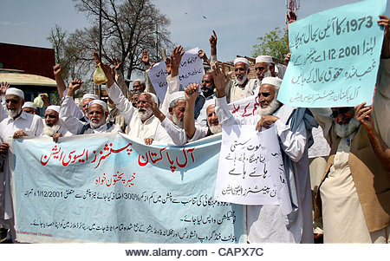

- 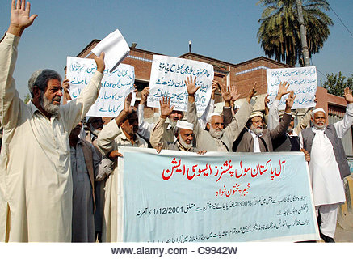

3000x2061px | 17.7MBDownload
Pensioners are protesting in favor of their demands during a demonstration arranged by All Pakistan Pensioners Association (APPA) at Peshawar press club
